January 1, 2026
To Whom It May Concern:
Thank you for your recent inquiry regarding our trusted food products. We appreciate the opportunity to provide you with information relevant to our food safety systems. As you are aware, each of our food processing establishments is subject to the United States Department of Agriculture (USDA) and/or the Federal Department of Agriculture (FDA) inspection as required by law. These establishments operate in accordance with all applicable regulations including, but not limited to, Hazard Analysis and Critical Control Points (HACCP), Hazard Analysis and Risk-Based Preventive Controls (HARPC), Sanitation Standard Operating Procedures (SSOP), Sanitation Performance Standards (SPS), and Good Manufacturing Practices (GMPs).
The finished product(s) you are purchasing from Tyson Foods, Inc. have not been irradiated as part of our production process.
We trust that this information has proven useful.

Respectfully,
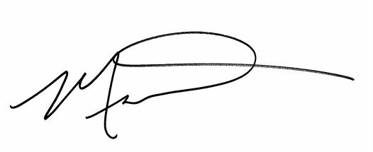
Michael Rybolt, Ph.D.
Sr. Vice president Food Safety & Quality Assurance
Global FSQA

